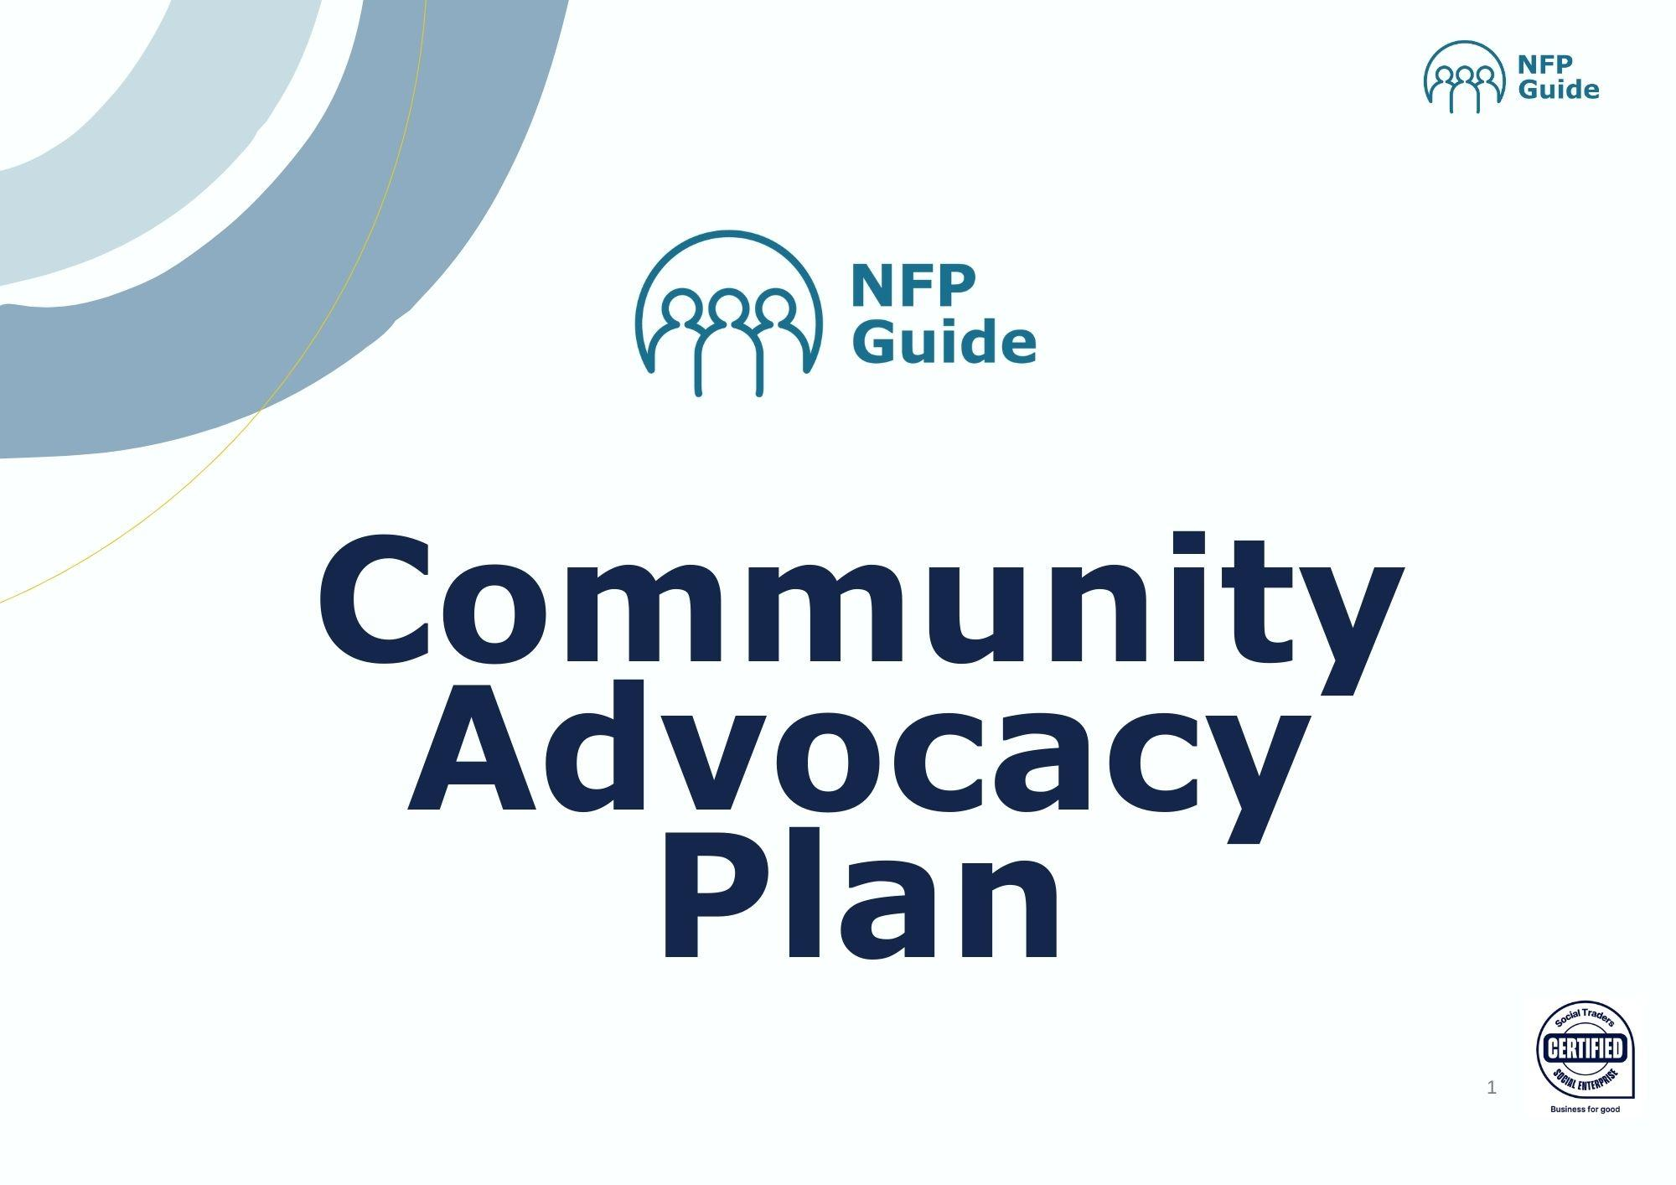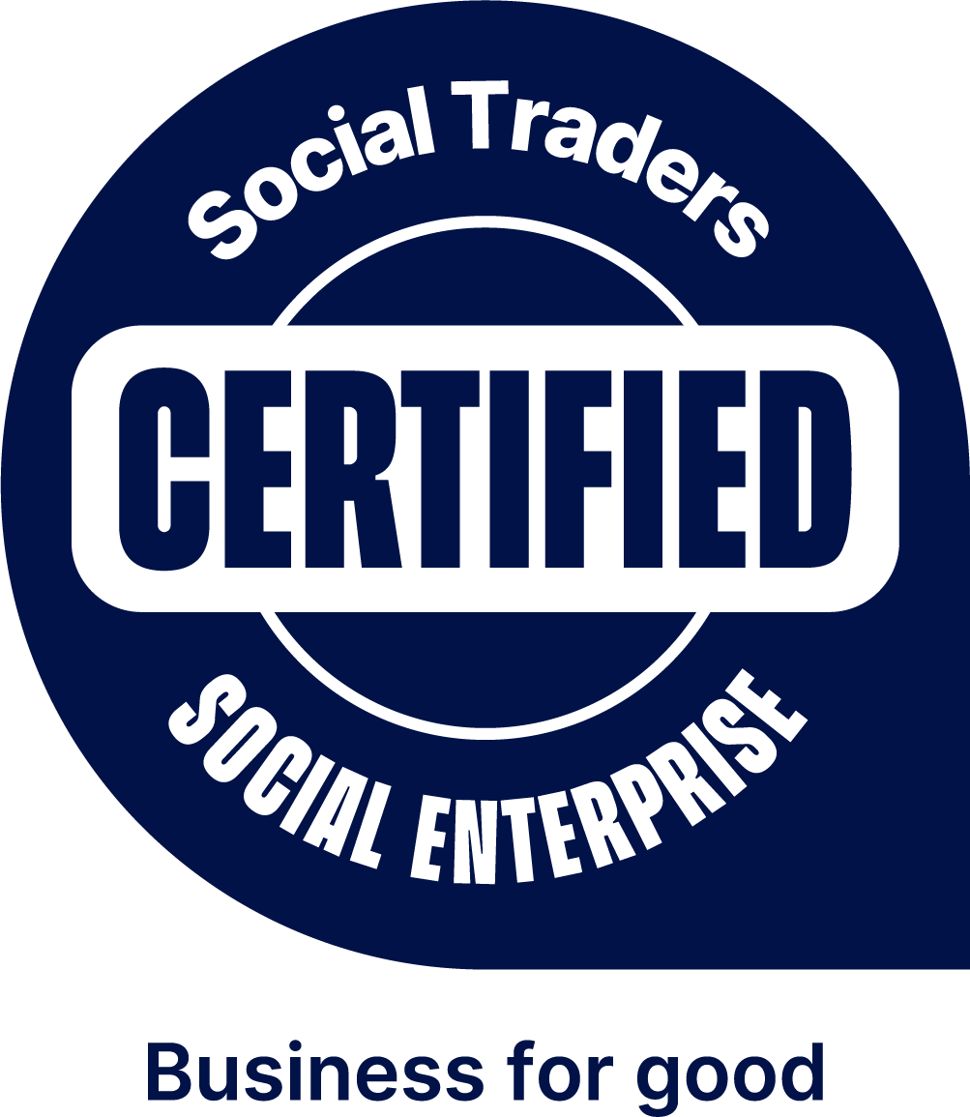­­­­­­­

|  |  |
| --- | --- |
| What is the issue? | Wh­­at will it look like when it’s fixed? |
| What needs to change for that to happen? | |
| What will happen if it’s not fixed? | |
| What stories and data do we have? | |

Who can influence that change?

Issue

High power, High interest

Low power, Low interest

Low power, High interest

High power, Low interest

|  |  |  |
| --- | --- | --- |
| My personal story | Impact Case Study | Collective Story |

**What are our key stories?**

**How do we get them to take action?**

|  |  |  |  |
| --- | --- | --- | --- |
| **Who** | **Why they should care (Key Message)** | **How they can help** | **Action** |
|  |  |  |  |
|  |  |  |  |
|  |  |  |  |
|  |  |  |  |
|  |  |  |  |
|  |  |  |  |
|  |  |  |  |

|  |
| --- |
| What resources, partnerships and networks can we access? |
| What do we need to do? |

Action plan

|  |  |  |  |
| --- | --- | --- | --- |
| What | Where | When | Who |
|  |  |  |  |
|  |  |  |  |
|  |  |  |  |
|  |  |  |  |
|  |  |  |  |
|  |  |  |  |
|  |  |  |  |