How to use this worksheet.
A theory of change is about what the change is that you want to make, and how you intend to make that change. It’s a model that helps you plan what you are doing, why you’re doing it and how you’ll achieve this change.
While the theory of change you may have seen is a complex model using a framework called a logic model, we are taking it back to basics with a simplified approach. In the second part of this series, we explore the logic model that helps you to build a visual theory of change.
This is a key step because you really need to be clear about what you are doing.
For example, iClick2Learns social impact is to contribute to building resilient, inclusive, and healthy communities. At iClick2Learn, we chose to focus on how to build sustainable community organisations that are one of the biggest contributors to achieve this social impact. We know that the way to build sustainable communities is to give volunteers and staff the knowledge, tools, and insights they need to do this critical work.
An example of this for iClick2Learn, shown below.
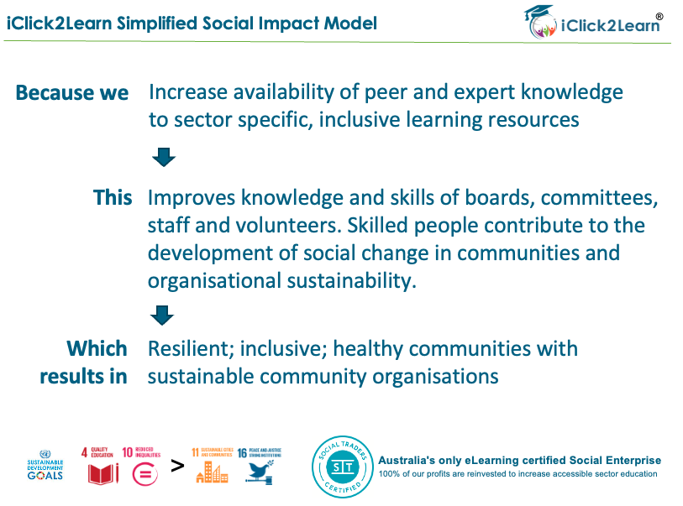

Now, it’s time for you to work out your Theory of Change.
You can start from what you currently do, or you can start with the end in mind, which is what the ultimate purpose is of your organisation. There’s no wrong or right. Our brains all think a bit differently. The key thing is if you are going to start at point 1 below, then critically assess it by going in reverse. For example, using iClick2Learns example we could say that we provide training but if we aren’t focused on what type of training, or who to then we’ll have less chance of creating social impact.
By focusing on what our goal is, and how we can best achieve that goal helps us narrow our focus to what we were created to do.

If we / because we do x

By / intervention of x

This results in

